Project 1

Ashley Roselius

Mateen Rizki

CS 6830

Before adding pesticide to the equation, the system seems to be stable. The pray and predator look to come and go in a constant rate and be a constant ring. Upon further inspection we see that when you zoom in it is not quite stable it is slowly spiraling in.

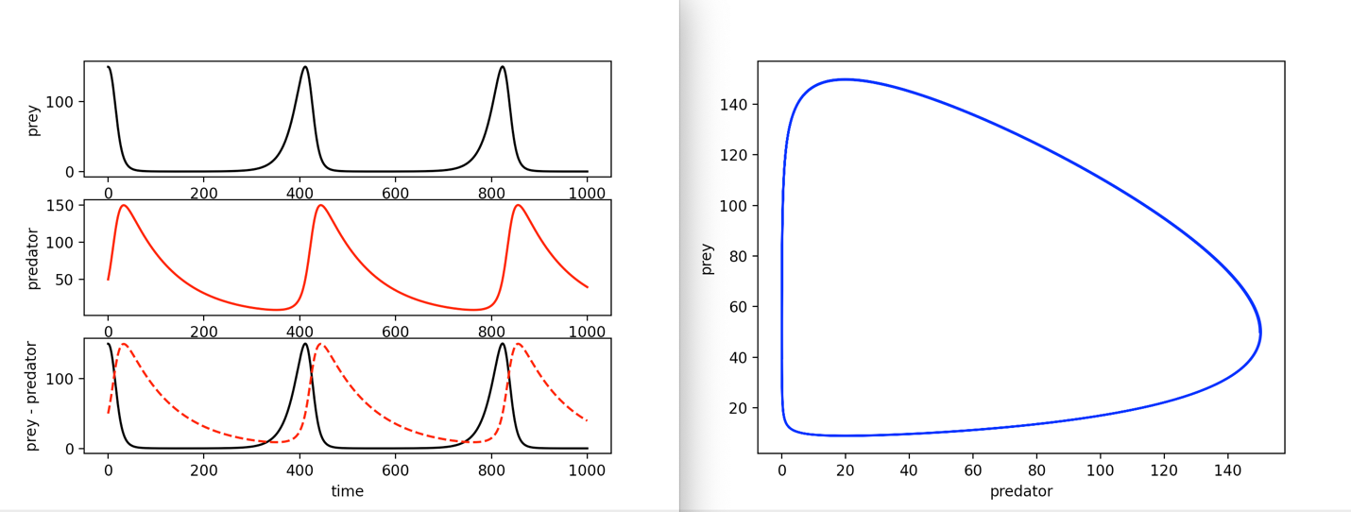

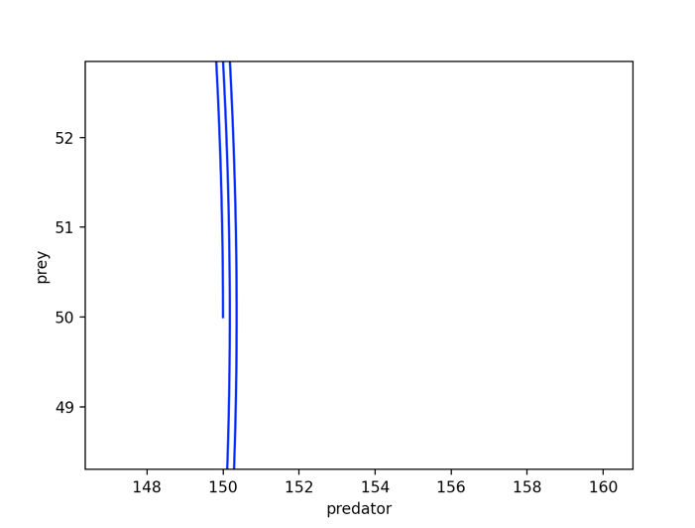

I played around with many numbers increasing different values. The following values are what I increased for the following images.

* preyBirth = 0.10
* preyDeath = 0.010
* initPrayWt = 200.0
* predBirth = 0.0010
* predDeath = 0.10
* initPredWt = 100.0

When increasing just the prey birth rate the insect(pred) population increased but the system seemed to be stable but still is slightly unstable as it is slowly spiraling in.

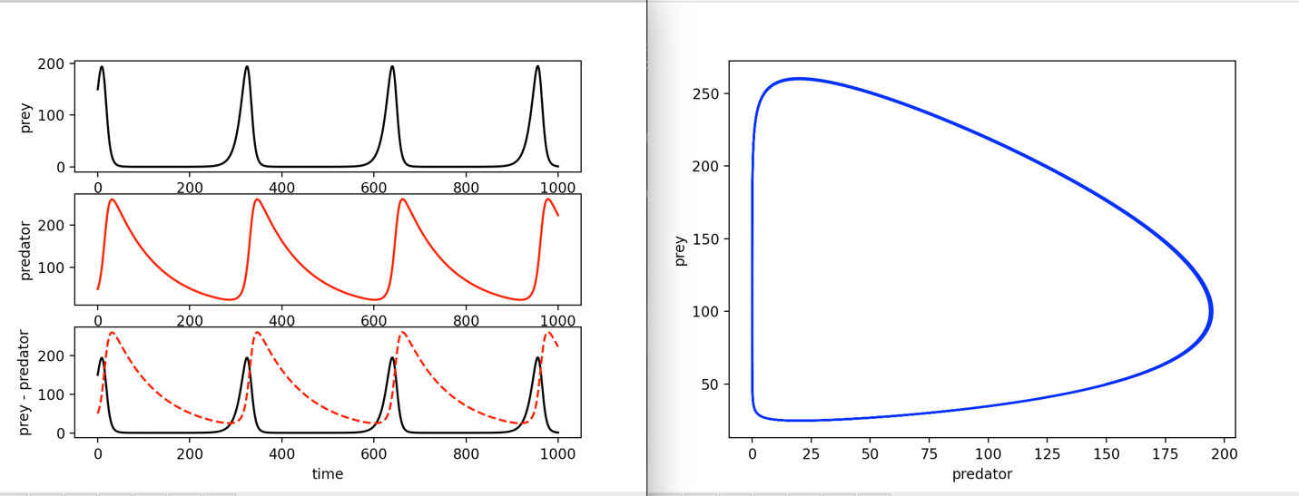

When increasing the prey death rate the population of both grass(prey) and insects(pred) decrease rapidly

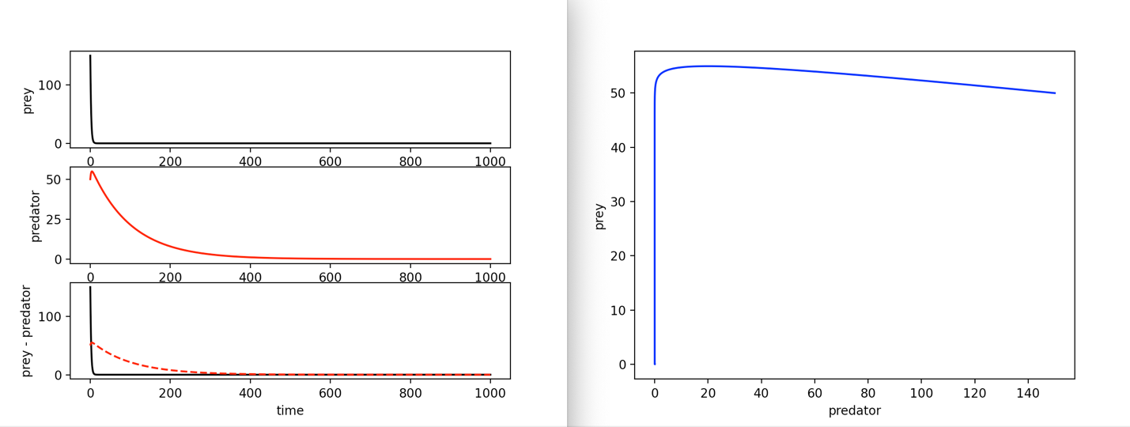

When increasing the initial prey value the spikes seem the slow in frequency and the system seemed to be stable but still is slightly unstable as it is slowly spiraling in.

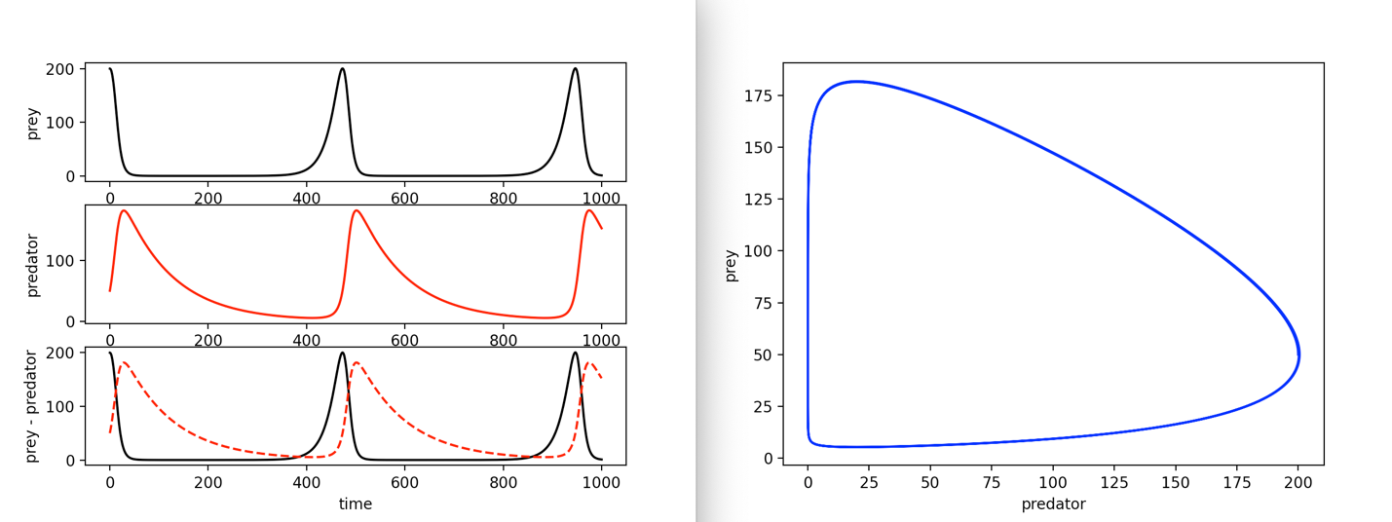

When increasing the pred birth rate the spikes are very far apart and the number of insects increase.

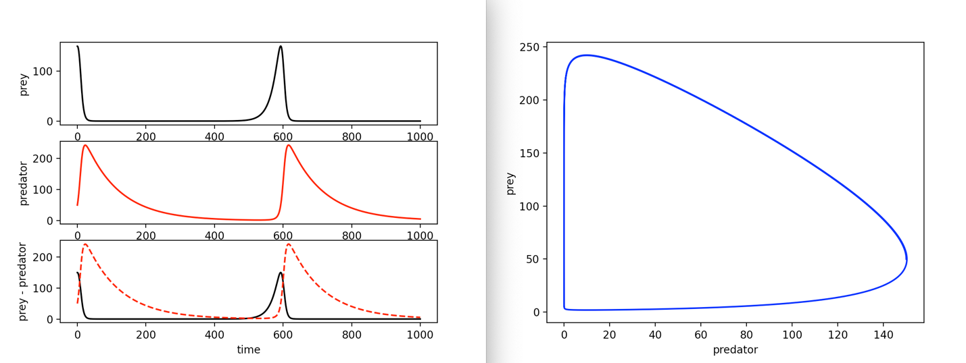

When increasing the pred death rate the spikes are very close together and the number of insects decreases while the grass(prey) increases. This looks to be the closest we have to stable but it is technically not stable yet as it is very slowly spiraling in still.

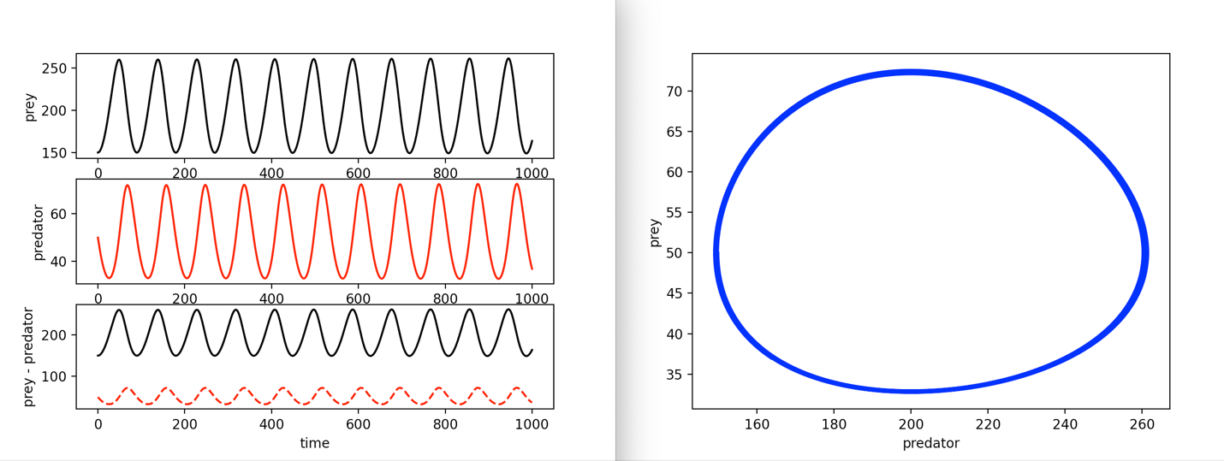

When increasing the initial predator value the grass gets very close to zero then spikes and falls again fast.

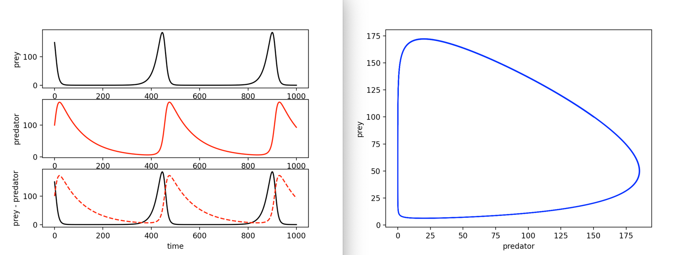

I have also decreased different values. The following values are what I decreased for the following images.

* preyBirth = 0.01
* preyDeath = 0.0001
* initPrayWt = 100.0
* predBirth = 0.0001
* predDeath = 0.001
* initPredWt = 25.0

When decreasing just the prey birth rate we got a got a heard and quick death for both grass and insects

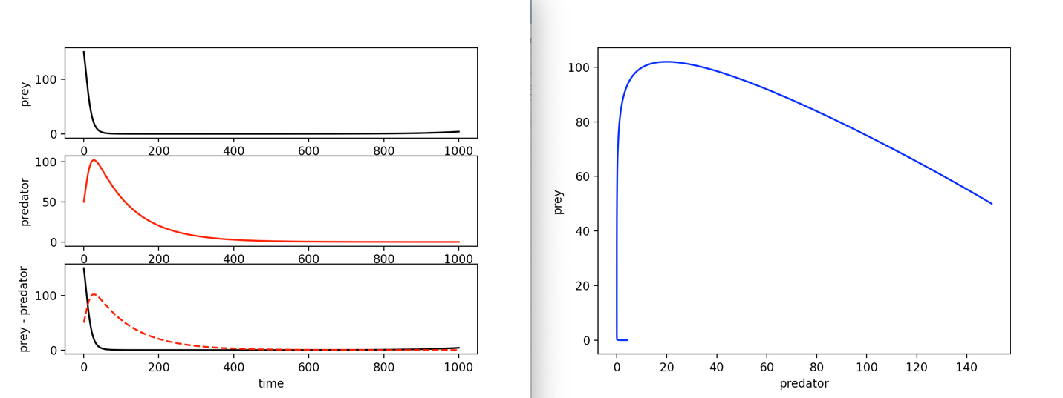

When decreasing just the prey death rate the insects value skyrockets

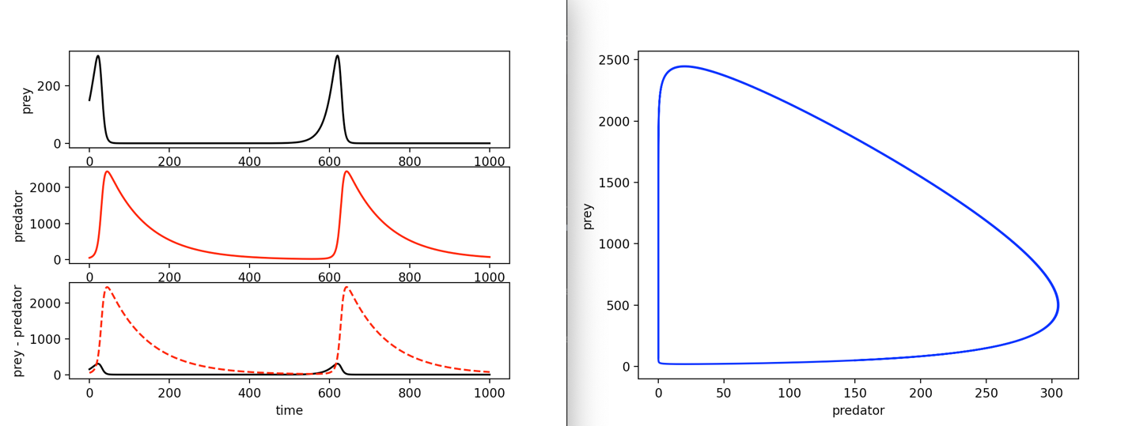

When decreasing just the initial value of the prey the the spikes seem the slow in frequency and the system seemed to be stable but still is slightly unstable as it is slowly spiraling in.



When decreasing just the pred birth rate the spikes are closer together and the number of insects decreases.

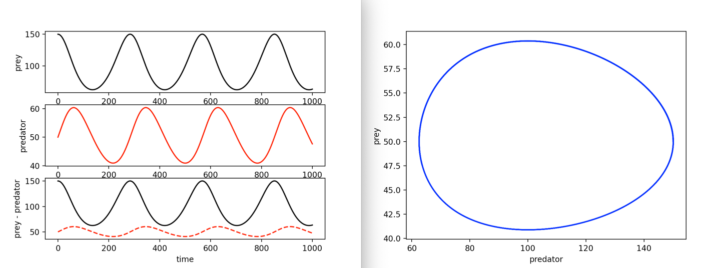

When decreasing just the pred death rate we got a got a heard and quick death for both grass and insects

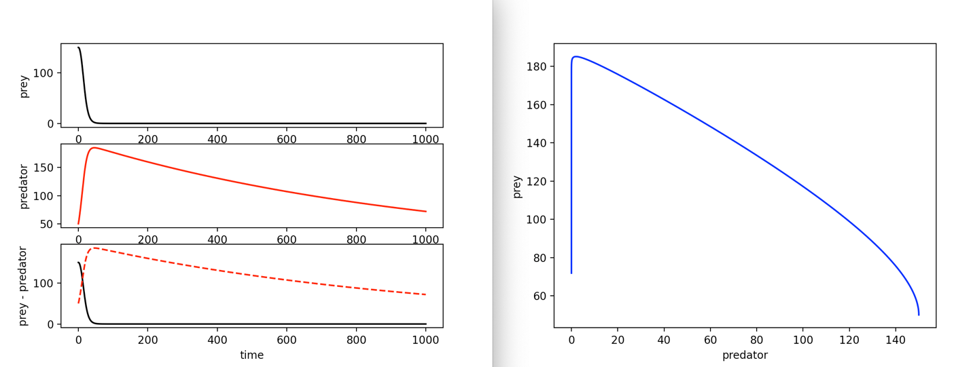

When decreasing just the initial pred value we get farther spikes.

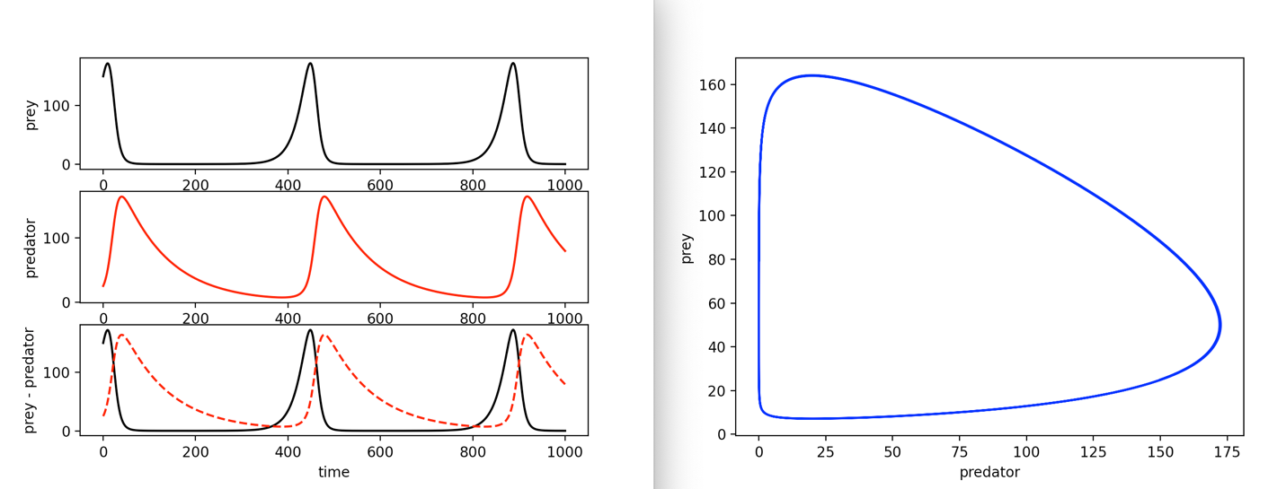

After playing around with the values and getting an understanding of the system I added in pesticide value to the functions. I added four values that I listed below. I Played around with these values to find the ones that worked the best and got the most stable result with the original values from the previous task.

* PesticideDecay = 0.01
* grassPesticideRate = 0.001
* insectPesticideRate = 0.9
* initialPesticide = 25.0

The following functions are the original functions:

The following functions include pesticides:

I chose to add it to the equation by multiplying by the effect rate of each and the amount of pred/prey left and the amount of pesticide left. This is because the effect rate to pred/prey should be a constant and will effect the remaining pred/prey based on how much pesticide is left.

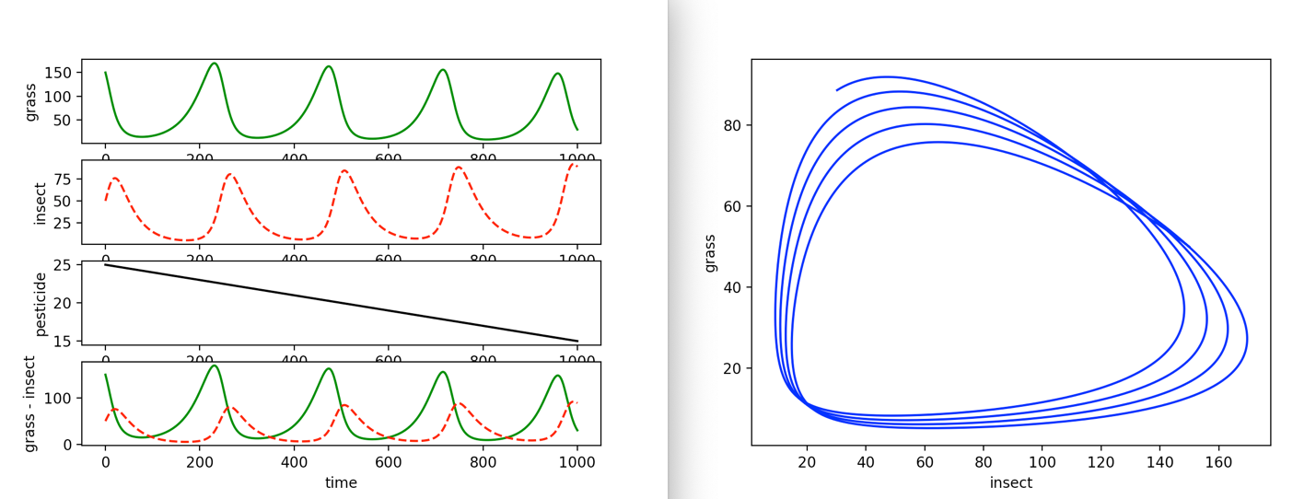

The loops in task one do not cross over but they do cross over in task two. They cross over in task two because the ratios between grass and insects change. Sometimes there is more grass and other times there are more insects because of the pesticides and how it effects the grass and insect population. Having the pesticides keeps the insect population down but does not get rid of them completely which keeps the grass population in check. When the insect population rises the grass population diminishes. So reapplying pesticide will need to happen to keep the insect population in check and keep the grass from dying off.